

DG MARKT
Framework Contract No DI/6769-2
Specific Contract No 4708

Digital Signature Services Post-Implementation
Technical Analysis
Software Architecture Document


ARHS Logo

Subject | Software Architecture Document
Version | 2.00
Release Date | 20/01/2012
Filename | 0000.doc
Document Reference | DSS2-SAD

Document History

Document History
Version | Deliverable | Release Date | Author | Description
0.01 | DLV 1.2 | 11/02/2011 | Christian Hiedels,  David Naramski | Version sent for Review
0.02 | DLV 1.2 | 11/03/2011 | Christian Hiedels | Updated with regards to comments received; removed “eID framework as basis”; Version sent for Acceptance
0.03 | DLV 1.2 | 22/03/2011 | Christian Hiedels | Updated according to post-delivery comments;  Version sent for Acceptance 2
0.03 | - | 19/04/2011 | Frank Meyer | Updated according to post-acceptance comments
0.90 | DLV 3.3 | 30/06/2011 | Christian Hiedels | Version sent for Review
1.00 | DLV 3.3 | 27/07/2011 | Christian Hiedels | Version sent for Acceptance
1.01 | DLV 3.2 | 06/01/2012 | David Naramski | Version sent for Review  Add reference document for ASiC
2.00 | DLV 3.2 | 20/01/2012 | David Naramski | Version sent for Acceptance

Reviews
Version | Release Date | Reviewer | Position
0.01 | 11/02/2011 | Frank Meyer | Project Manager
0.02 | 11/03/2011 | Frank Meyer | Project Manager
0.03 | 22/03/2011 | Frank Meyer | Project Manager
0.04 | 19/04/2011 | Christian Hiedels | Senior Analyst Programmer
0.90 | 30/06/2011 | Frank Meyer | Project Manager
1.00 | 27/07/2011 | Frank Meyer | Project Manager
1.01 | 06/01/2012 | Frank Meyer | Project Manager
2.00 | 20/01/2012 | Frank Meyer | Project Manager

Table Of Contents

1 Introduction 10
1.1 Purpose of the Document 10
1.2 Scope of the Document 10
1.3 Intended Audience 10
1.4 Structure of the Document 10
2 Architectural Aspects 11
2.1 Architectural Goals 11
2.1.1 Extensibility 11
2.1.2 Reliability 12
2.1.3 Versatility 12
2.1.4 Adaptability 12
2.2 Architectural Constraints 13
2.2.1 Open Source 13
2.2.2 Software Infrastructure 13
3 Use-Case View 15
4 Logical View 16
4.1 Overview 16
4.1.1 TLManager 16
4.1.2 DSS/Web 16
4.2 Architecturaly Significant Design Packages 17
4.2.1 Web Layer 17
4.2.2 Webservice Layer 18
4.2.3 Service layer 18
4.2.4 PKIX API 18
4.2.5 XML Digital Signature 18
4.2.6 BouncyCastle 19
4.2.7 iText 19
4.3 Use-Case Realisations 20
4.3.1 TLManager 20
4.3.2 DSS 21
5 Implementation View 26
6 Deployment View 28
6.1 TLManager 28
6.2 DSS/Web 28
7 Extension Points 30
7.1 Signature Format 30
7.2 Document formats 30
7.3 Document Visualisation 30
7.4 Human readable output of a TL 31
7.5 Other Signature Media and Integration of SmartCards with PC/SC 31

List of Tables

Table 1: Reference Documents 6
Table 2: Applicable Documents 7
Table 3: Abbreviations and Acronyms 9

List of Figures

Figure 1: Layers of TLManager 16
Figure 2: Layers of DSS 17
Figure 3: Working with Trusted Lists 20
Figure 4: Signing of Trusted Lists 20
Figure 5: Signing of Documents 21
Figure 6: Validation of Signatures 22
Figure 7: Extension of Signatures 24
Figure 8: Components of the DSS system 27
Figure 9: Deployment Diagram for TLManager 28
Figure 10: Deployment Diagram for DSS 29

Reference and Applicable Documents
This section contains the lists of all reference and applicable documents. When referring to any of the documents below, the bracketed reference will be used in the text, such as [R01].

Reference Documents
Ref. | Title | Reference | Version | Date
R01 | Services Directive 2006/123/EC | 2006/123/EC | 1.00 | 12/12/2006
R02 | Commission Decision 2009/767/EC (corrected version) | CD 2009/767/EC | 1.00 | 14/11/2009
R03 | Commission Decision 2010/425/EU | CD 2010/425/EU | 1.00 | 28/07/2010
R04 | XAdES Specification | ETSI TS 101 903 | 1.4.2 | 12/2010
R05 | CAdES Specification | ETSI TS 101 733 | 1.8.3 | 01/2011
R06 | PAdES Specification | ETSI TS 102 778 part 1-6 | 1.1.x | 07/2010
R07 | e-Contract/eID Framework | https://www.e-contract.be | - | -
R08 | DSS Design Model | DSS2-DM | 1.01 | 04/01/2012
R09 | Java EE 6 Specification | JSR 316 - http://jcp.org/en/jsr/detail?id=316 | 1.00 | 10/12/2009
R10 | DSS Functional Analysis | DSS2-FAD | 1.01 | 04/01/2012
R11 | Spring | http://www.springframework.org | 3.0.5 | N/A
R12 | ETSI TSL Conformance Checker | http://212.234.160.9 | N/A | N/A
R13 | PC/SC Workgroup Specifications Overview | http://www.pcscworkgroup.com/specifications/overview.php?open=2 | 2.01.9 | 04/2010
R14 | Commission Decision CD 2011/130/EU | CD 2011/130/EU | 1.00 | 26/02/2011
R15 | Electronic Signatures and Infrastructures (ESI); Associated Containers (ASiC) | ETSI TS 102 918 | 1.1.1 | 04/2011
Table 1: Reference Documents

Applicable Documents
Ref. | Title | Reference | Version | Date
A01 | Framework Contract ESP DESIS II – Lot 2 | DI/6769-2 | N/A | 25/02/2011
A02 | Specific Contract | SC 4708 | N/A | 10/10/2011
A03 | “Quoted Time & Means” Form # 3 | QTM-T3 | N/A | 21/10/2011
Table 2: Applicable Documents

Abbreviations and Acronyms

Abbreviations and Acronyms
Abbreviation | Meaning
AdES | Advanced Electronic Signature
API | Application Programming Interface
ASiC | Associated Signature Container
BES | Basic Electronic Signature
CA | Certificate Authority
CAdES | CMS Advanced Electronic Signatures
CMS | Cryptographic Message Syntax
CRL | Certificate Revocation List
CROBIES | Cross Border Interoperability of eSignatures
DSS | Digital Signing Service
EJB | Enterprise Java Beans
EPES | Explicit Policy based Electronic Signature
ETSI | European Telecommunications Standards Institute
EUPL | European Union Public License
FedICT | FPS Information and Communication Technology Communication
FPS | Federal Public Services
FSF | Free Software Foundation
GUI | Graphical User Interface
JAXB | Java Architecture for XML Binding
JCA | Java Cryptographic Architecture
JCE | Java Cryptography Extension
Java EE | Java Enterprise Edition
LGPL | Lesser General Public License
LOTL | List of Trusted Lists
LTV | Long Term Validation
MIT | Massachusetts Institute of Technology
MVC | Model View Controller
OCSP | On-Line Certificate Status Protocol
ODT | Open Document Text
OOXML | Office Open XML
OSI | Open Source Initiative
OSS | Open Source Software
PAdES | PDF Advanced Electronic Signatures
PDF | Portable Document Format
PKCS | Public Key Cryptography Standards
PKI | Public Key Infrastructure
PKIX | Internet X.509 Public Key Infrastructure
PSC | Point of Single Contact
QC | Qualified Certificate
SD | Service Directive
SOA | Service Oriented Architecture
SOAP | Simple Object Access Protocol
SSCD | Secure Signature Creation Device
TL | Trusted List
TSL | Trustservice Status List
WSDL | Web Services Description Language
WYSIWYS | What you see is what you sign
XAdES | XML Advanced Electronic Signatures
Table 3: Abbreviations and Acronyms

Introduction

Purpose of the Document
The aim of this document is to provide a comprehensive architectural overview of the Digital Signature Services (DSS) system. This document describes how functional analysis and use cases are translated and structured in the architecture by the development team.

Scope of the Document
This document is part of the Technical Analysis and it frames the necessary views to represent the software architecture, as well as give information about the framework, tools and technologies used.

Intended Audience
The present document is intended to be read by the following teams, but not limited to:
- DG MARKT Team;
- Development Teams.

Structure of the Document
The document is organised as follows:
- Chapter 1 - Introduction summarises the purpose and scope of the document, and lists the intended audience.
- Chapter 2 - Architectural Aspects outlines the topics that have the biggest influence on architectural decisions.
- Chapter 3 - Use-Case View presents use cases, which have architectural coverage or stress a specific aspect of the architecture.
- Chapter 4 - Logical View presents the decomposition of the software architecture into subsystems and packages.
- Chapter 5 - Implementation View describes the overall structure of the implementation model, the decomposition of the software into layers and subsystems.
- Chapter 6 - Deployment View describes the physical infrastructure on which the DSS software is deployed and specifies the physical nodes that executes the software.
- Chapter 7 - Extension Points gives an overview of possible extensions to project DSS.

Architectural Aspects
This chapter describes the software requirements and objectives that have significant impact on the architecture. This chapter also captures the constraints that apply due to the architectural choices.
The technical annex of the contract demands two different software applications, released as Open Source Software (OSS):
- Trusted List(s) creation, editing and maintaining;
- E-signature creation and verification.
There are no direct architectural connections between both. Although they may use same packages, they will be deployable and functional on their own.
Thus, it makes sense to split the DSS (Digital Signature Services) system in three significant sub-systems:
- DSS Core is the set of classes that act as foundation providing the fundamental functionalities.
- TLManager is the standalone application, executable on local computers and based on Java Swing, that permits the creation, editing and maintaining of Trusted Lists (TL) and Lists of Trusted Lists (LOTL).
- DSS/Web is a server application that permits the creation of AdES and their verification with the help of a TL.
There is a business connection in the way, that TL/LOTL created by TLManager may be used as basis by DSS/Web to verify signatures. It is up to the MS to decide when and how TLManager and DSS/Web will be used.

Architectural Goals
This section describes the software requirements and objectives that have impact on the architecture of DSS, specifically DSS/Web built on top of DSS Core:
- Extensibility;
- Reliability;
- Versatility;
- Adaptability.
The section also presents the architectural choices that meet these technical requirements.

Extensibility
DSS will be publicly available as open source and shall be suited as base for further developments primarily by MS. Thus, the system will be designed to include hooks and mechanisms for extending/enhancing the sub-systems with new capabilities without having to make major changes to the original infrastructure. The used Spring framework (cf. [R11]) will ensure that different modules and aspects can be glued easily together.
This goal will be achieved by following directives:
- The system will provide suited interfaces and organized packages to extend and adapt functionality, where it seems appropriate. Possible extension points that are already identified are detailed in chapter 7 - Extension Points. Throughout the development phase even more may be identified.
- The functionalities of DSS can be easily integrated into other applications by usage of well defined web services.
- A detailed documentation in English will ensure that the system is well described and easily understandable.

Reliability
The project DSS is the implementation of requirements in Commission Decision 2009/767/EC [R02] (amended by Commission Decision 2010/425/EU [R03]) and in Commission Decision 2011/130/EU [R14] (these all are further referenced as “The Commission Decisions”). It is expected to respect all the specifications therein and to produce correct signatures according to the Decisions, as well as to validate only well formatted signatures with the help of TL/LOTL, which may be created with TLManager (and TL created by other means, which follow the specifications of The Commision Decisions).
Signatures or Trusted Lists that don’t respect the specification or the required security will not be supported by DSS/Web. This includes data which is not well formatted, as well as data that is not in accordance with business rules defined in [R10], all to be listed in validation reports as detailed as possible.
Furthermore, because of the legal aspect of eSignatures, it must be possible to validate them at any time in the future. DSS will return deterministic validation results; if the same input data is provided twice, the results will always be equal. Reports on validity will be given in a comprehensive and comprehensible way and not just reduced to a ‘valid’ or ‘invalid’ status.

Versatility
DSS will represent a complete coverage of the whole topic of easing the cross-border verification of Advanced eSignatures (AdES) supported by a Qualified Certificate as specified by The Commission Decisions.
Although the functional complexity is rather small, DSS has to implement every signature format of XAdES, CAdES, PAdES and ASiC. Furthermore it has to be able to parse all types of TL and LOTL, which may not necessarily originate from TLManager but have to be compliant with the CDs specifications.

Adaptability
The field of application for project DSS may be on an unknown number of different systems in unknown environments. To emphasize adaptability, only the very essential requirements and dependencies about the environment are assumed. This should allow MS to easily adapt DSS/Web to their situations and integrate it in the most flexible way possible.

Architectural Constraints

Open Source
The entire source-code of DSS will be released under an open source license. This restricts the usage of libraries and third-party tools to those that are compatible with the chosen licence. The proposed license for DSS is GNU LGPL 2.1, approved by OSI.

Software Infrastructure
Following decisions were made regarding the operational and technical environment:
- DSS requires the installation of Java Runtime Environment and SSCD drivers;
- DSS/Web is web based and accessible from supported web browsers;
- DSS/Web is built based on Java EE technology (Spring MVC).

These decisions infer the following constraints on the software infrastructure that will run the system:
- Software provided by MS
  - Oracle Java 1.6
  - Arbitrary Application Server compliant to Java EE specification (cf. [R09])
  - Internet Explorer 6 to 8 or Mozilla Firefox 3 (with Java 1.6 plugin)
both in a 32 bit version
- Third party software provided by Arηs Developments
- iText 2.1.7 – Mozilla Public License 1.1 (redistributable under GNU LGPL 2 or above)
- BouncyCastle 1.38 – Adaption of MIT License
- Apache XML Security – Apache License 2.0
- Spring 3.0.5 – Apache License 2.0 (cf. [R11])

Software Licenses
The following licenses are used for the software provided by Arηs Developments:
- Mozilla Public License – http://www.mozilla.org/MPL/MPL-1.1.html
- GNU LGPL 2.0 / 2.1 – http://www.gnu.org/licenses/lgpl.html
- MIT License – http://www.bouncycastle.org/licence.html, http://opensource.org/licenses/mit-license.php
- Apache License 2.0 – http://www.apache.org/licenses/LICENSE-2.0.html

Changes to Open Source Libraries
It may be possible to change code in one or more of the provided open source libraries. More specifically, iText has to be adapted to prevent it from adding own information to a PDF file when writing it. Otherwise the digest of a document would be invalidated each time a document is written with the help of iText.
Any amended library will be provided in the changed form by Arηs Developments.

Use-Case View
This chapter lists the use cases which were identified as having a significant architectural impact. However, these are use cases from an architectural point of view, so they may not have direct counterparts in the use cases detailed in the Use Case Model document (cf. [R10]).

Use Cases for TLManager
Name | Description
Working with Trusted Lists | An actor can create a Trusted List or a List of Trusted Lists from scratch or from a file saved locally and can save the progress made at any time.
Signing of Trusted Lists | An actor can sign a Trusted List or a List of Trusted Lists with the help of a connected (Secure) Signature Creation Device ((S)SCD) or with a Keystore.

Use Cases for DSS/Web
Name | Description
Signing of Documents | An actor can sign a document with all types of X/CAdES (up to -A), ASiC-S and PAdES (up to -LTV) signatures.
Validation of Signatures | An actor can validate documents with all types of X/CAdES (up to -A), ASiC-S and PAdES (up to LTV) signatures.
Extension of Signatures | An actor can extend the signature format of a signature in a document to a higher level; starting from BES/EPES up to A.

Logical View

Overview
TLManager and DSS/Web do have different architectures. One is a standalone Swing-based tool, the other is a Java EE web-based application. The following chapters give an overview over the different layers, before every key component is explained more in detail below in chapter 4.2 - Architecturaly Significant Design Packages.

TLManager
TLManager is a standalone program with an intuitive GUI that permits to create any kind of Trusted List (TL) and everything about them will be manually editable (except some values which are predefined in configuration files; cf. [R10]). Also it will enable the user to create and edit a List of Trusted Lists (LOTL). These lists can be signed according to signature data provided by the user. Its user interface will be internationalized, as well as support common accessibility features (as provided by the Swing framework). It will implement a traditional MVC pattern.
The Data Model contains all the information about the TL/LOTL being edited.
The software relies on key components of Java 6:
- JAXB enables the application to read and create XML representations of TL/LOTL;
- XML Digital Signature will provide functionality to sign TL/LOTL with XAdES-BES signature;
- Java Security API permits the communication between TLManager and three signing media: PKCS#12 files, PKCS#11 tokens and MS Capi stores.

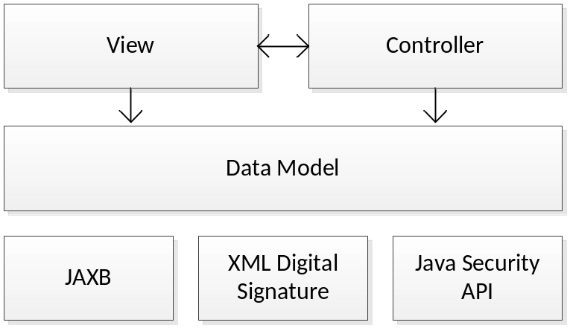
Figure 1: Layers of TLManager

DSS/Web
DSS/Web presents a classical multiple tiers Java EE architecture. Its core services are accessible via two tracks: one is a standard Web Layer that uses a Java Applet on client sides to communicate with signing devices and the other are webservices that expose the signing and validation functions.
Also several other general packages are used, like PKIX API, XMLSecurity, BouncyCastle and iText.
The packages are shown in more detail below in individual chapters.

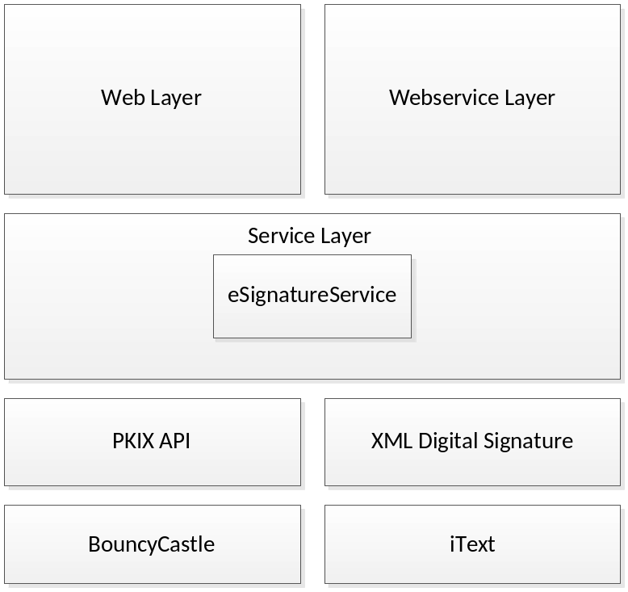
Figure 2: Layers of DSS

Architecturaly Significant Design Packages

Web Layer
DSS provides an intuitive web interface that gives access to an applet, which guides the user through the essential steps for validation or signing of documents. This layer is based upon Spring MVC.
Spring MVC is a highly flexible framework that allows any object to be used as command or form object and does not impose any restrictions on the code.

Signing and Validation Applet
For signing or validating a document, an applet is loaded into the browser, which may interact with a smart card reader and communicates with the Service Layer for verification of certificates. Operations on documents will be performed directly in the applet itself, so it is not necessary to send out the document to the DSS server.
It is important to note, that outgoing connections from the applet will be performed only to the DSS Server. If the applet needs to contact a TSP or OCSP server to retrieve timestamp or status information, it does not connect to those servers by itself, but calls the DSS Server for this kind of information. The Service Layer will forward such requests to DSS, which connects to a respective server or returns suited data from its cache.

Webservice Layer
Webservices are a way to expose all or a set of operations of a software system, so that they are accessible over a network with a common protocol like HTTP. The definition of a webservice follows a specific format called WSDL, which describes the available operations. Other software systems can follow this specification and request webservices, as well as retrieve responses within SOAP messages.
DSS will expose its main Use Cases via a set of well-defined web services (cf. [R08]). They will essentially allow other systems to validate a signature or to sign a provided document.
For securing the channel between other systems and the webservices of DSS, Transport Layer Security is used. This way, it can be ensured that the transferred data was not tampered with.
Nevertheless, it will not be possible to perform the actual signing of the digest of a document in a web service, because the private key to perform this step can not be exposed over the network.

Service layer

ESignatureService
The ESignatureService is the core service of DSS and provides the functionality of creating and verifying eSignatures. Moreover, it can integrate signatures in documents and contacts a TSP Server when a TimeStampToken is needed.
It creates XAdES, CAdES, PAdES and ASiC signatures, adds signature support for PDF (PAdES) and Binary (CAdES) file formats and allows raising XAdES signing to level ‘A’.
The handling of different document formats is separated in individual modules, referred to as Document Format Modules (cf. Use Case 4.3.2.1 - Signing of Documents). This ensures extensibility for further document formats.
Furthermore, for being able to validate any AdES signature, it is necessary to check on the validity of their respective certificates. This is checked by scanning through a chain of certificates and returning the validation status and data of the whole chain up to a trust anchor.
A cache is maintained in a configurable database for storing certificate status information that was retrieved earlier from a CRL Server. The released implementation will use a HSQL database that stores data in-memory, as it is not expected to keep CRL and certificate status information for a very long time. Still, data can be kept over server restarts, by exporting/importing it to the filesystem.

PKIX API
The PKIX API is an integral part of Java and provides many functions for handling PKI related operations. It contains several algorithm-specific classes for building and validating X.509 certificates. Moreover, it provides classes and interfaces for validating and building of certification paths.
For checking the revocation status of a certificate, the library can retrieve a CRL from a repository, or check dynamically for the status by doing OCSP requests.

XML Digital Signature
The Java XML Digital Signature Reference Implementation in Java 6 is a pluggable framework built on the Java Cryptographic Architecture (JCA). It provides support for various implementations of digital signature algorithms and transformations:
- Canonicalization of XML;
- Calculation of digests;
- Generation of enveloped/detached XML signatures;
- Verification of XML signatures.

BouncyCastle
BouncyCastle is the name of a library that collects a large number of commonly used cryptographic interfaces. It provides different algorithms for calculating digests, performing creation of signatures and several utility functions for convenience. It abstracts the functionality of Java Cryptographic Extension (JCE) in a more lightweight version, which is especially suited for memory-constrained environments like Applets.
Furthermore, it has packages for creating CMS, which is necessary for creating signatures of binary or PDF files (CAdES or PAdES).

iText
The iText API is essentially used to manipulate PDF documents. Although the API provides many possibilities, in DSS it is used to programmatically extract signatures from provided PDF documents to evaluate them, or to attach signatures to non-signed PDF documents.
It may be used as well for a future version of TLManager, to create the human readable output of a TL/LOTL, as detailed in chapter 7.4 - Human readable output of a TL.

Use-Case Realisations

TLManager

Working with Trusted Lists
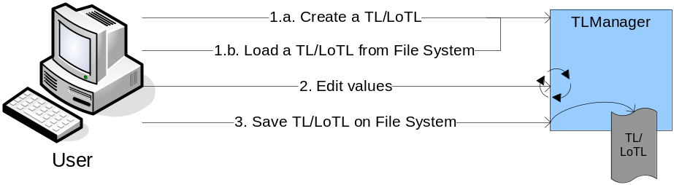
Figure 3: Working with Trusted Lists
- The actor can create a new blank Trusted List (TL) or List of Trusted Lists (LOTL), or load a previously saved list from a file system. The data format will always be XML and already following the correct syntax/semantic of a TL/LOTL as specified by The Commission Decisions, completed by ETSI TS 101 203 (v3.1.2).
- With the help of GUI elements that abstract the format of a TL/LOTL in an intuitive manner, the actor is able to enter or choose values. TLManager verifies the given values to guide the user as much as possible.
- The current progress of a TL/LOTL can be saved onto the file system at any time. It will be stored in a single file, which can be loaded again as described in the first step.

Signing of Trusted Lists
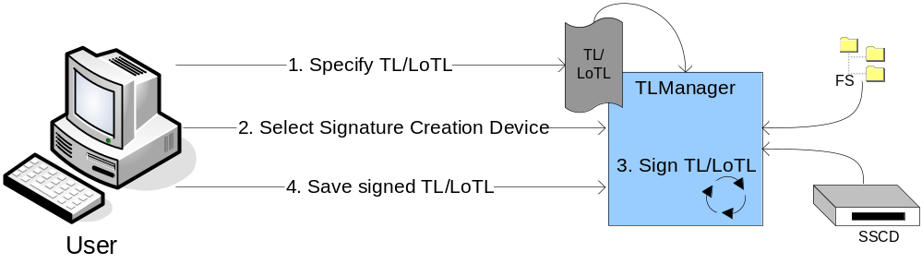
Figure 4: Signing of Trusted Lists
- The actor loads a previously saved Trusted List (TL) or List of Trusted Lists (LOTL) into TLManager, or he continues from an already loaded list.
- He chooses a certificate from either a PKCS#11 token, or a PKCS#12 or MS CAPI certificate, which resides on a file system (FS).
- A digest is calculated, which is given to the (S)SCD and signed automatically or the key is retrieved from a keystore and the signature will be calculated. This signature is formatted into XAdES (BES) and attached to the TL/LOTL.
- The user saves the signed TL/LOTL to a file system.

DSS

Signing of Documents
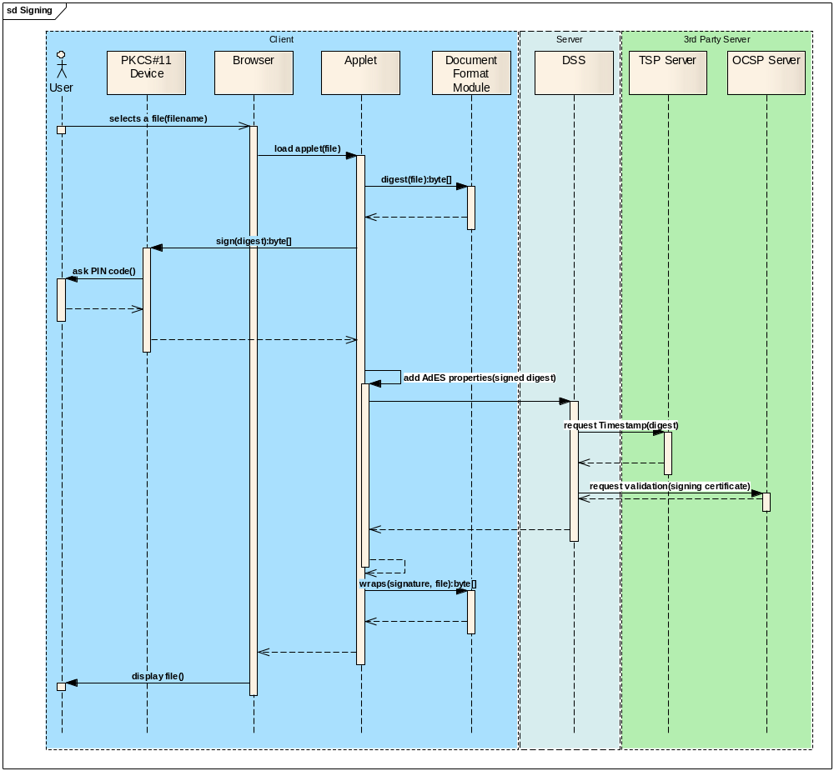
Figure 5: Signing of Documents

- The actor selects an unsigned document from his local filesystem, on which an applet will operate. The applet will be started from the current session of the DSS/Web.
- The applet determines the type of the file and instantiates a Document Format Module that is specific for the type of the file. This module calculates the digest of the file.
- The digest is given to the driver of the signing device (here exemplarily a PKCS#11 device), whose driver asks the user for a PIN code. The certificate is returned to the applet.
- The applet enriches the signature with AdES properties, depending on the kind of signature (X, C or P), by using its integrated lightweight eSignature Service.
- In the case of an AdES-T (-X, -A) signature, a TSP Server will be contacted through the DSS Server to register the digest and return a timestamp, which will be added to the AdES properties.
- In the case of an AdES-C signature, an OCSP Server will be queried additionally to determine wether the certificate is still valid or whether it was revoked meanwhile.
- The AdES properties are returned to the applet, where they will be integrated in the document, by the appropriate Document Format Module.
- The finalized document can be stored onto the filesystem of the actor for further usage.

Validation of Signatures
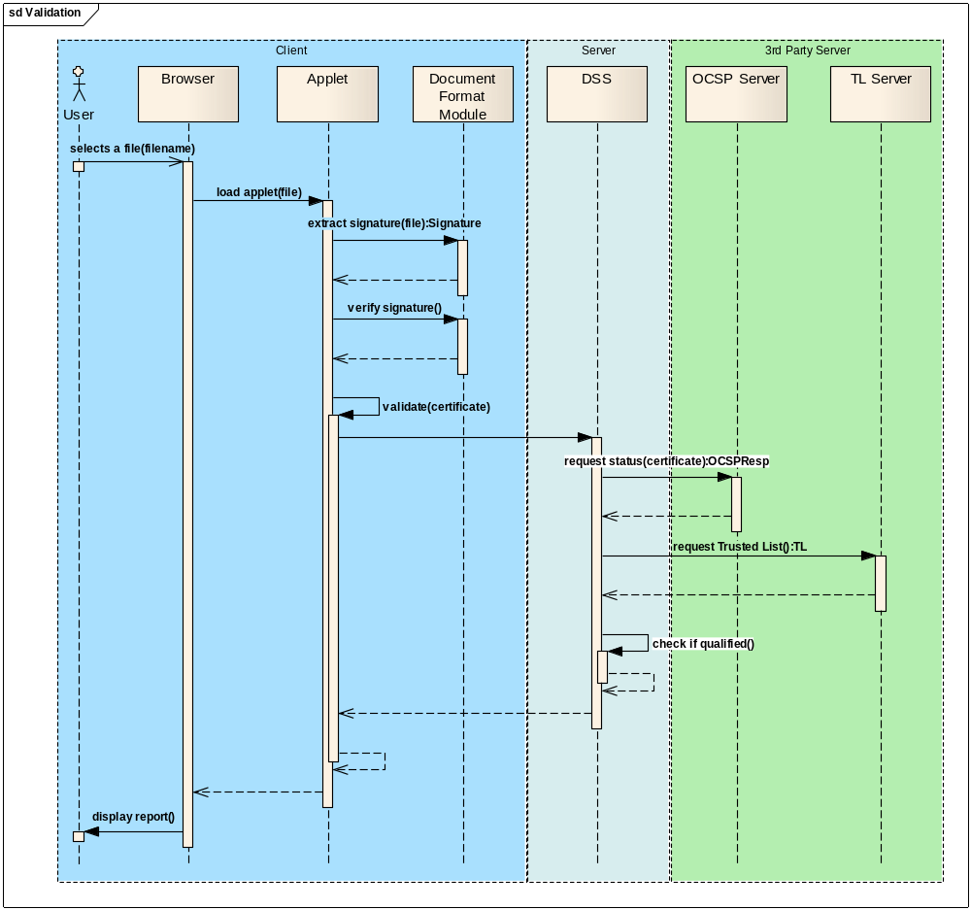
Figure 6: Validation of Signatures
- The actor selects a signed document from his local filesystem, on which an applet will operate. The applet will be started from the current session of the DSS/Web.
- The applet determines the type of the file and instantiates a Document Format Module that is specific for the type of the file. This module extracts the signature from the file.
- After having the signature part extracted, the applet calls again the Document Format Module for a semantic verification of the signature. If error or inconsistencies are discovered at this step, the actor will be notified and the process is interrupted.
- In the next step, the signature will be validated by the DSS Server. The revocation status of the given certificate may be requested from an OCSP Server (depending on the type of signature) and the Trusted List is retrieved from the appropriate TL Server.
- With the data retrieved in the previous step, it can be determined, whether the certificate is fully qualified. For this, a chain of certificates must be constructed from the signing certificate to one of the certificate contained in the Trusted List. Then, with information in the Trusted List and the content of the signer’s certificate, it can be determined whether or not the signature is created by a SSCD and what the constraints are that the signing certificate has to follow in order to be rated as “Qualified Certificate”.
- The result is given back in form of a detailed report and displayed to the user.

Extension of Signatures
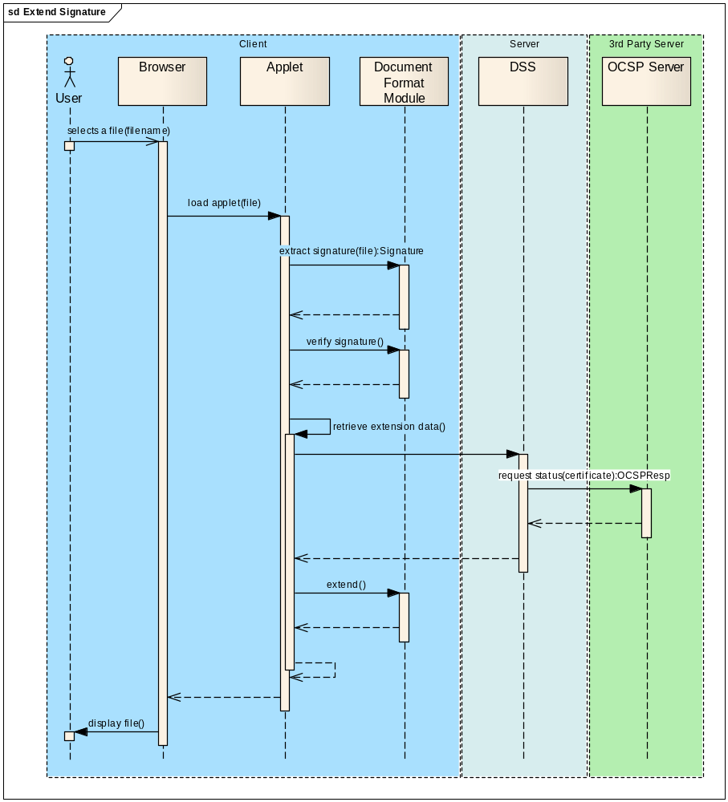
Figure 7: Extension of Signatures

- The actor selects a signed document from his local filesystem, on which an applet will operate. The applet will be started from the current session of the DSS/Web. Furthermore, the actor specifies the level of signature to which the signature shall be extended to.
- The applet determines the type of the file and instantiates a Document Format Module that is specific for the type of the file. This module extracts the signature from the file.
- After having the signature part extracted, the applet calls again the Document Format Module for a semantic verification of the signature. If error or inconsistencies are discovered at this step, the actor will be notified and the process is interrupted.
- In the next step, additional signature information has to be retrieved, depending on the type of the source and target signature format. (In the example, BES/EPES is assumed to be extended to XL.)
- The DSS Server contacts an OCSP Server to retrieve status information about the certificates of the document.
- The retrieved data is given back to the applet, from which the Document Format Module is called again to integrate the new information, thus extending the source signature format to a higher level.
- The finalized document can be stored onto the filesystem of the actor for further usage.

Implementation View
The implementation view describes the overall structure of the implementation model and the decomposition of the software into modules and components.
The Digital Signature Services project is composed of two independent applications, which will partially be based upon the same modules.
On the very left side of the graph, both application modules are symbolized. TLManager is able to mark TL/LOTL with XAdES signatures, so it integrates the Document Trust for XML that is also used by the Signing and Validation Applet, which again is used by DSS/Web. The trust modules for CMS (DocTrustBinary) and PDF (DocTrustPDF) are not needed when working with TLManager, but are available for DSS/Web.
Another package that is used in common is about parsing Trusted Lists. It is incorporated in TLManager, but is also used by the TrustServices of DSS.

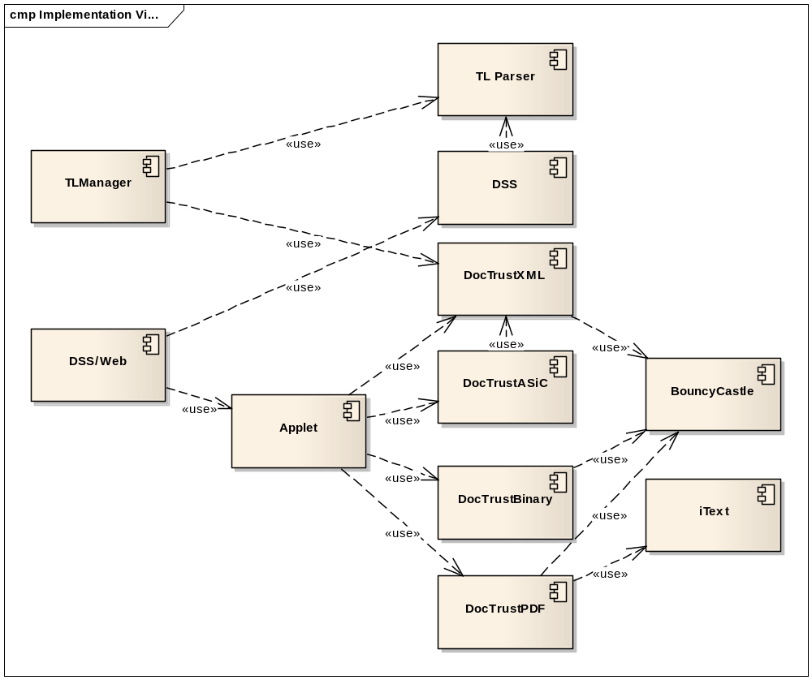

Figure 8: Components of the DSS system

Deployment View
This section lists the different physical nodes on which the application is deployed, as well as showing other nodes which may be contacted by the application. Altogether, this poses a requirement on the infrastructure, as respective nodes have to be established, or access to already existing nodes has to be provided.
The view is split into two sections according to the different sub projects. Both deployments can be accomplished without any relation between the two.

TLManager
TLManager is a standalone GUI tool, based on Java Swing, which is deployable on every Desktop PC that has a Java 6 environment.
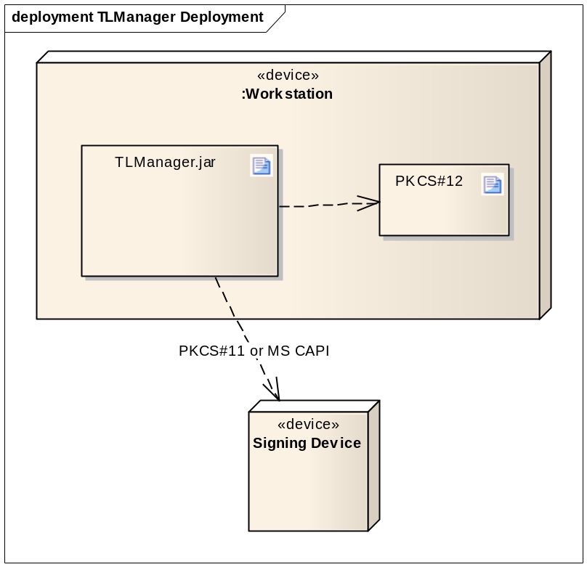
Figure 9: Deployment Diagram for TLManager

DSS/Web
DSS/Web is a web application based on the Spring framework (cf. [R11]), that can be deployed onto common Application Servers, with the only constraint that the server has to be compliant to the Java EE specification (cf. [R09]). The Application Server resides in the infrastructural premises of different Member States.
For validation of certificates, connections will be established to external OCSP and CRL servers (detailed in the certificates), specified for individual CA/QC Providers from a TL. These external connections can be done with HTTP or HTTPS.
To support timestamping, DSS may contact a TSP server. Connections can be done either by HTTP or HTTPS, depending on the TSP server.
For retrieving the LOTL, and other TL of MS, further outgoing connections will take place, all using HTTPS.
All outgoing connections from DSS will be configurable to adapt them to the respective infrastructure, except connections to servers which hold TL of MS. Those connections will depend on the information found in the LOTL.

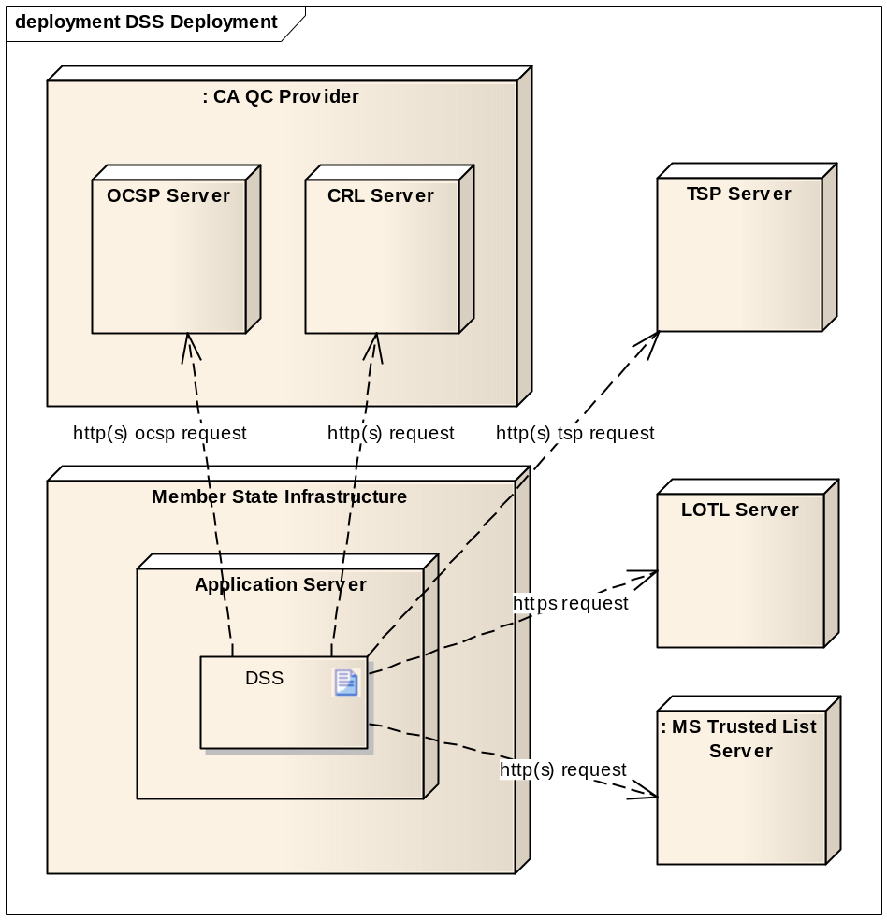
Figure 10: Deployment Diagram for DSS

Extension Points
This chapter lists points that might be developed as extensions in the future for both TLManager as well as DSS/Web. Although these extensions may represent usefull features, they do not affect the basic functionality of the software and are considered as posing no impact upon the architecture.

Signature Format
DSS will support the four signature formats specified by ETSI:
- XAdES (cf. [R04]);
- CAdES (cf. [R05]);
- PAdES (cf. [R06]);
- ASiC (cf. [R15]).
For creating the signature, DSS will conform to the specification according to a Profile. These profiles may define another view on the list of used elements and are detailed in [R10].
As an extension, it may be possible to modify the behaviour of the creation of signatures by specifying other profiles.

Document formats
The DSS will distinguish three types of document formats:
- XML;
- PDF;
- Binary files;
- ASiC files.
These formats cover the four types of signature, respectively XAdES, PAdES, CAdES and ASiC. Further document formats will be easily introducible, by implementing appropriate interfaces. E.g. the XML based ODT and OOXML.

Document Visualisation
It is a common approach, that systems that are able to calculate electronic signatures should follow the “What you see is what you sign”-paradigm. That means, that the user should be always fully aware of what exactly he is going to sign. Nevertheless, the document formats supported by DSS (cf. 7.2 - Document formats) won’t be shown in a browser, because they do not have own visualizers. Instead a generic view listing the available document properties is shown.
Developers will be able to add custom visualizers to tailor the displaying of document formats to their needs.

Human readable output of a TL
TLManager will be able to create a TL/LOTL in XML format, which is considered to be ‘machine-processable’ (MP). The creation of a ‘human-readable’ (HR) format will be left out and can be implemented additionally in the future. Several decisions have to be taken to decide on the exact appearance of this format, according to Chapter IV of [R02] and [R03].
However, the ETSI TSL Conformance Checker (cf. [R12]) is likely to be able to generate pdf representations of given TL/LOTL.

Other Signature Media and Integration of SmartCards with PC/SC
For further support of signature media other than PKCS#12 files, PKCS#11 tokens and MS CAPI stores, TLManager and the Applet used with DSS will provide a well-defined interface.
With the PC/SC standard (cf. [R13]) integrated directly into Windows Operating Systems and available for Linux Systems with additional drivers, Java (since version 1.5) can be used to talk to every SmartCard for which a detailed specification is known. Thus, a specific implementation may be needed for every SmartCard, which is further detailed in the Design Model (cf. [R08]).

End of Document

Except for PAdES “Part 5” signature specification.
Note that this license chapter has been reviewed on 11/03/2011 by OSOR.eu (the Open Source Observatory and Repository for European public administrations) finding compatibility with the targeted DSS LGPL license.

